Below screenshot shows the creation of database and table-

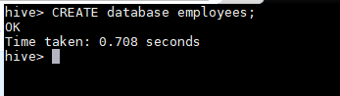

We are using similar file used as that in Task-1 but we are adding an extra column as “greet” . Below is the DDL query-

**create table emp3**

**(**

**emp_id int,**

**emp_name string,**

**sal int,**

**dept int,**

**greet string**

**)**

**ROW FORMAT DELIMITED**

**FIELDS TERMINATED BY ','**

Below is the screenshot-

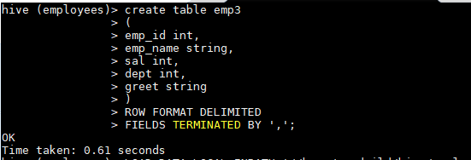

After that we loaded data in the table emp3 using below command-

* **LOAD DATA LOCAL INPATH ‘/home/acadgild/hve/employee_details2.txt’**
* **INTO TABLE employees.emp3;**

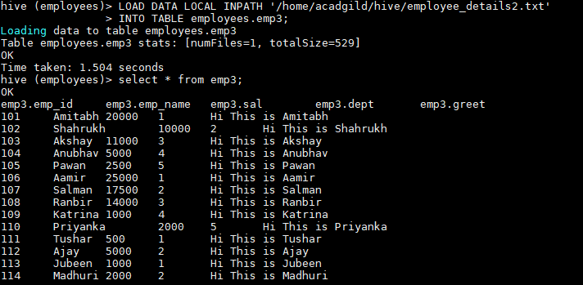

After that we are adding JAR created from the JAVA class which is defining the UDF using below syntax-

* **ADD JAR /home/acadgild/hive/hive-task2.jar;**

After that we are creating a temporary function “conct” using below syntax-

* **CREATE TEMPORARY FUNCTION conct AS ‘udf.ConcatStr’;**

After that we run below query to take one column (NAME) input as String and another column(greet) as Array of Strings and concatenate them-

* **SELECT emp_id, sal, dept, conct(emp_name, greet) FROM emp3;**

Below is the screenshot for the same-

